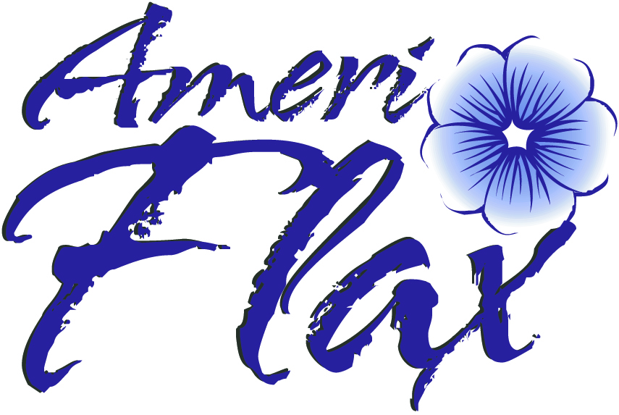INSTRUCTIONS FOR PROPOSALS FOR PROJECTS IN
FLAX UTILIZATION RESEARCH AND FLAX PRODUCTION RESEARCH TO AMERIFLAX

SUBMIT TO:
Lindy Coleman at - lcoleman@ndpci.com.
In addition, please send one signed copy to:
AmeriFlax
125 Slate Drive, Suite #4
Bismarck, ND, 58503

- Application Form.

- Project budget including funds from other sources.
3. A brief summary on the application form and an Executive Summary not to exceed
two single-spaced pages, and a proposal following the same guidelines as those
required for a proposal to the North Dakota Agricultural Products Utilization
Commission now. Other or additional or modified guidelines may be developed and required in the future.

- A verification letter is required from any other agency listed to provide partial
funds to support this project or indicate this proposal has been submitted to NDAPUC for their reaction (late).

- Indirect funds or “overhead Funds” from AmeriFlax are not permitted in compliance with the policy of North Dakota on “Commodity” organizations
receiving crop “levy” funds.

Applications and detailed proposals will be considered by AmeriFlax usually within one month of submission and the person/agency submitting the proposal will be notified of AmeriFlax action.

- An interim progress report and a final report to AmeriFlax is required. The final report must be submitted before the final payment of grant funds is made.

- The results of the research or the production promotion activities will be submitted
for publication in popular or referred journals upon completion of the project.

BASIC AND APPLIED RESEARCH GRANT FORM

AA. APPLICANT INFORMATION

Applicant/Contact
Name: ____________________________________
Address: ____________________________________
____________________________________
City, State, Zip: ____________________________________
Phone: ____________________________________

BB. GENERAL DESCRIPTION OF THE PROJECT

1. Grant application amount: $______________________

2. Briefly describe the project.

3. Briefly describe the outcome expected from this research.

4. Describe any previous research done in this particular research area.

5. Explain the methodology to be used in the research including:

a) objectives;
b) research approach;
c) methods;
d) scientific design;
e) research sites; and
f) anticipated timelines necessary to complete the project.

6. How will the flax producers benefit from this research project?

7. List project co-sponsors (including: name of organization, address, telephone, key contact, nature of participation) and attach a letter of intent to participate for each co-sponsor.

8. List of principal investigator(s) and other members of the research team. Resumes, no longer than 2 pages per member; must be attached to the application.

9. Please list the names and phone numbers of two references who are familiar with the applicant’s work:

Name: _____________________ Name: ________________________
Address: _____________________ Address: ________________________
_____________________ ________________________
City, State: _____________________ City, State: ________________________
Zip: _____________________ Zip: ________________________
Phone: _____________________ Phone: ________________________

CC. INSTRUCTIONS

10. SUBMIT TO: Lindy Coleman at lcoleman@ndpci.com.
In addition, please send one signed copy to:
AmeriFlax
125 Slate Drive, Suite #4
Bismarck, ND, 58503

DD. CONCLUSION

By affixing their signature(s) to this application, the applicant(s) certify that they have read and understand the guidelines governing award of these grants and agree to all conditions set forth therein and that all information contained in this application package is true to the best of the applicant’s knowledge, information and belief.

AmeriFlax reserves the right to modify or terminate any subsequent agreements with applicant if, at a future date AmeriFlax becomes aware of material misrepresentation(s) contained in this application.

Name: _________________________________
(type or print)

Signature: _________________________________

Title: _________________________________

Date: _________________________________

SUPPLEMENT A
Statement of Potential Funding Sources

PREVIOUS FUNDS RECEIVED FOR THIS PROJECT:
(list additional sources on another sheet of paper, if necessary)

Source: ______________________________________
Address: ______________________________________
Amount: ______________________________________

Source: ______________________________________
Address: ______________________________________
Amount: ______________________________________

Source: ______________________________________
Address: ______________________________________
Amount: ______________________________________

SUPPLEMENT B
Project Budget
Expenditure | AmeriFlax | Other Funds | Total
Salaries/Fringe Benefits
(Name recipients & anticipated amount for each)
Equipment/Supplies
(Specify)
Travel
(Specify)
Printing Costs or Publication
(Specify)
Computer Lease or Rental Costs
Consultant Fees - Attach copy of RFPs, if any
(Break out & identify the cost of each source)
Other Direct Costs
(Specify)
Indirect Costs
(Specify - NDOC does not fund indirect costs)
Total

Only matching costs which are directly related to this phase of the project will be considered.
SUPPLEMENT C
Press Release Information Sheet

The information on this sheet may be used for public releases in announcements, press releases and other public information.

Applicant: __________________________________________________________
Contact Person: __________________________________________________________
Address: __________________________________________________________
__________________________________________________________ __________________________________________________________
Telephone: __________________________________________________________
Project Co-Sponsor(s): __________________________________________________________
__________________________________________________________
Title of Project: __________________________________________________________
__________________________________________________________
Start-Up Date: __________________________________________________________
Completion Date: __________________________________________________________

Brief Summary of the project, product or process and proposed commercialization efforts:
______________________________________________________________________________
____________________________________________________________________________________________________________________________________________________________
______________________________________________________________________________

Total funds requested from AmeriFlax: _____________________________________________
Total project budget: _____________________________________________
What will the grant funds be used for? _____________________________________________
__________________________________________________________________________________________________________________________________________________________________________________________________________________________________________
______________________________________________________________________________

Name and Title:_______________________________________
(type or print)

Signature:_______________________________________

Date:_______________________________________

